Magic: the Gathering - Fiendslayer Paladin
Embiggen the image and listen to the sound effects here :
http://soundjax.com/lightsaber-1.html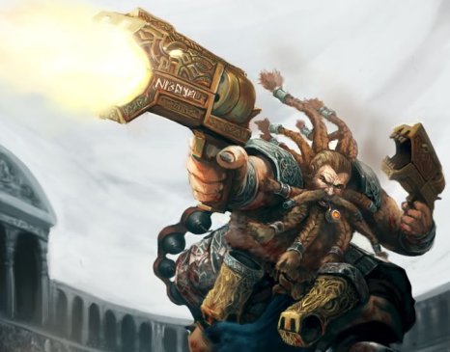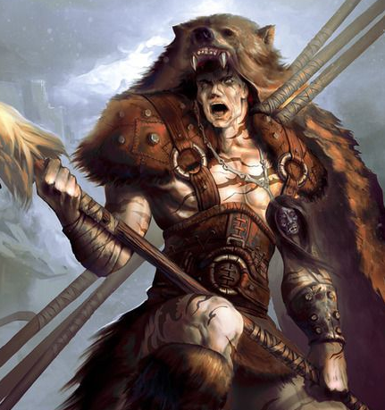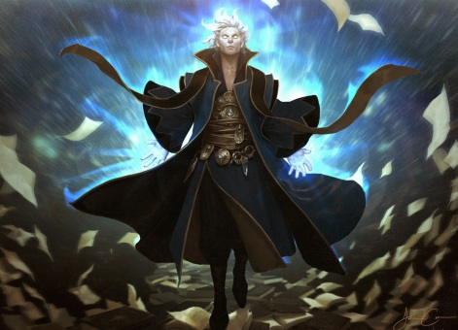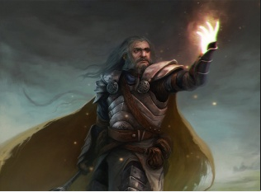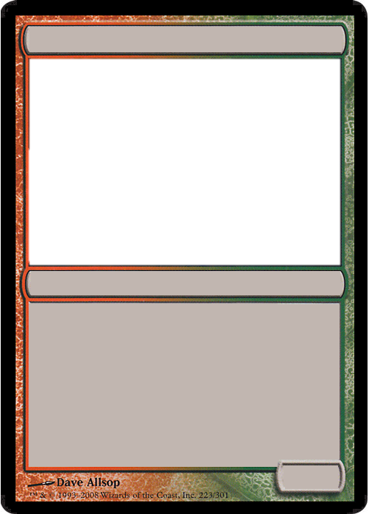

Waldo, of the Shade

Waldo, of the Shade

AC:

PP:

XP:

Korfbjorn Wildmaul

Korfbjorn Wildmaul

AC:

PP:

XP:

Uthal Dragonhunter

Uthal Dragonhunter

AC:

PP:

XP:

Hymdall Baggins

Hymdall Baggins

?

AC:

PP:

XP:

Juldak Hammerbeard

Juldak Hammerbeard

AC:

PP:

XP:

Baston “The Great…”

Baston “The Great…”

AC:

PP:

XP: